Preliminary Draft for HP/LP Column Box, Argon Box Site Joining Procedure

General note:

The following procedure is intended as a guideline. The shop fabricator and site contractor are ultimately responsible for establishing a final executable splitting and rejoining procedure for the S210 column box and Argon Box that is safe and satisfies the intent of the design. The shop fabricator and site contractor may deviate from this procedure per their discretion. Any significant deviation must be documented accordingly and submitted to Air Products engineering.

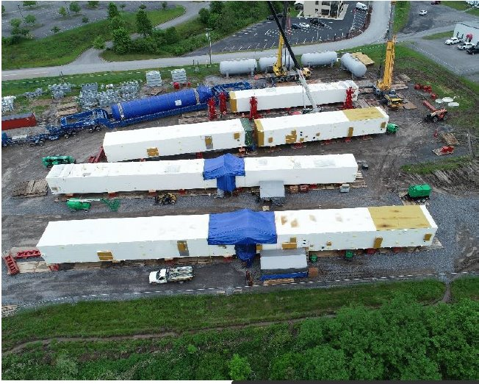

Rejoining the box and other misc steps at site:

Sl No | Activity | CLIENT | AP
1 | Position the upper & lower S210 box sections / Argon Box sections in the horizontal position on level support stands at shipping beam /cribbing locations. For possible locations see “Shipping and Handling” drawing (to be issued in Detailed Engineering). | X
2 | Remove all shipping sealing materials (e.g. tape, plastic, etc.) and carefully grind off tack welds attaching the sealing panel to the permanent frame members. Unbolt lower and upper box section temporary shipping protection frames per the site contractor notes on drawing (to be issued in Detailed Engineering). Remove all the threaded plugs from both the upper and lower box section chord sealing plates shown in details on drawing (to be issued in Detailed Engineering). Lastly, remove all shipped loose items (e.g. panels pipe spools, instrument tubing, etc.) from the lower and /or upper sections of the S210 box. | X
3 | Ensure the cutting end of column to follow AA cleaning per AP standard SPEC-ENG-MS094. |  | X
4 | Reposition upper & lower S210 box sections on level support stands so that they are approximately 30mm away from each other. | X
5 | Use a safe and suitable pulling system (e.g. come-alongs, chain pulls through trunnions and/or lashing lugs on both separated box sections etc.) to pull the box sections together using the stabbing cone. For details see DWG TBD. | X
6 | Install pipe spacers between joining lugs with the threaded rods to set correct spacing between the lower and upper sections (drawing to be issued in Detailed Engineering) | X
7 | Box to be aligned and leveled per AP specification 4WMA-007017. Column to be aligned and leveled per AP specification 4WMA-007017 or consult with AP vessel engineer. The site contractor to verify that the lower and upper sections of the S210 box are adequately supported near the join line to eliminate stress in the chords from dead loads. | X
8 | Weld all chord members per drawing (to be issued in Detailed Engineering). The alignment plates act as backer plates to facilitate completion of the full penetration bevel welds. After all chord splice welds are completed, nondestructive tests (NDT) must be performed. The NDT results must be submitted to the APCI site construction supervisor at site. For specific requirements, see notes on QS5053 note 12 (to be issued in Detailed Engineering). | X
9 | Weld HP/LP upper and lower column sections together per drawing (to be issued in Detailed Engineering)  NDT shall be performed per vessel related document. | X  NDT | X  Welding
10 | Remove all yellow painted temporary equipment supports. | X
11 | Remove all threaded rods and carefully grind off all joining lugs. | X
12 | Install all shipped loose diagonals per drawing (to be issued in Detailed Engineering). | X
13 | Install shipped loose panels of front face per drawing (to be issued in Detailed Engineering). | X
14 | Remove temporary carbon steel bracing as shown on drawing (to be issued in Detailed Engineering). | X
15 | Remove shipping covers from pipe ends - see drawing for details (to be issued in Detailed Engineering). |  | X
16 | Ensure the cutting end of cutting lines to follow AA cleaning per standard SPEC-ENG-MS094. |  | X
17 | Connect & weld ISCB pipes per drawing(to be issued in Detailed Engineering), including aluminum, SS, CS & instrument piping. |  | X
18 | All site pipe welds to be 100% radiograph tested, socket welds to be Dye pen tested. The NDT results must be submitted to the APCI site construction supervisor at site. | X
19 | Remove all yellow painted temporary pipe supports. |  | X
20 | Remove all site fabrication debris from inside of box. |  | X
21 | Pressure test for rejoining welds including column and piping. | X
22 | Install other shipped loose panels as per drawing (to be issued in Detailed Engineering). | X
23 | Touch-up final paint per AP specification 4WEQ-6804. | X
24 | Erect the S210 column box. | X

Please refer to Appendix 19B for the site support and coordination by client with some pictures for better understanding.

